Zidoo X6 Pro mediaspeler
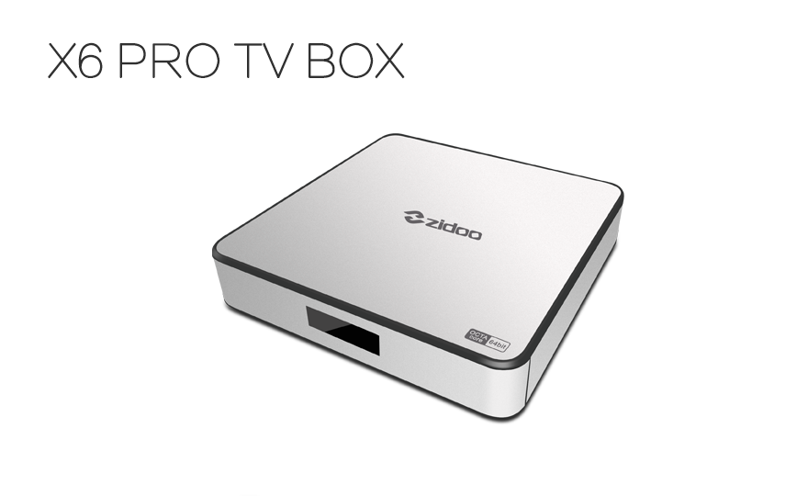
- http://www.zidoo.tv/Product/index/model/X6+Pro/target/18jaPkicAyZKKmVViAFMcQ%3D%3D.html
- ZIUI over Android 5.1
- Addons: http://www.alphr.com/software/1001693/best-kodi-addons-in-2016-the-13-best-xbmc-extensions-for-uk-users
- Ondertitels instellen: http://www.tvkijkenviainternet.eu/instellingen/ondertitels-instellen-kodi/

