Synology DS 107+
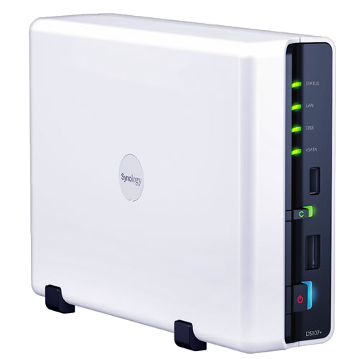Synology SD107+
DS107+ NAS met 1TB harddisk en Marvell Orion mv5281 ARM processor.
- Handleiding
- http://www.synology.com/support/download.php?lang=nld&b=1%20bays&m=DS107%2B

Packages
- http://www.synology.com/dsm/dsm_app.php?lang=us
- http://synoblog.superzebulon.org
- http://www.synocommunity.com/

Config
- Webserver coonfig /usr/syno/apache/conf

