Samsung UE32H5500 TV
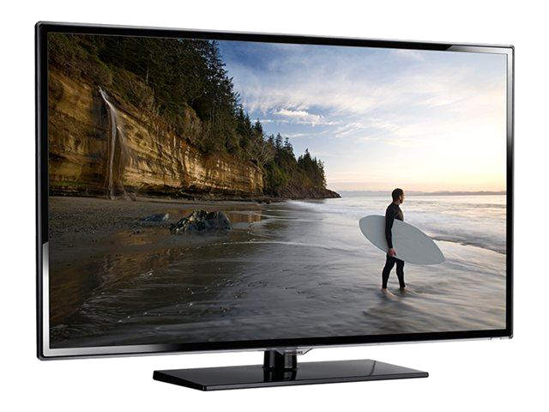Samsung UE32H5500
- http://www.samsung.com/nl/consumer/tv-audio-video/televisions/led-tv/UE32H5500AWXXN
- Handleiding (NL)
- Firmware Update manual

