Samsung S5230 Star
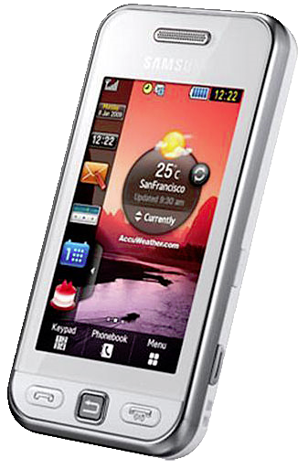Samsung S5230
- Samsung S5230 Star site
- http://www.samsung.com/nl/consumer/mobile-phone/mobile-phones/mobile-phone/GT-S5230LKAXEN/index.idx?pagetype=prd_detail&returnurl=
- Handleiding

