Raspberry Pi model 4b
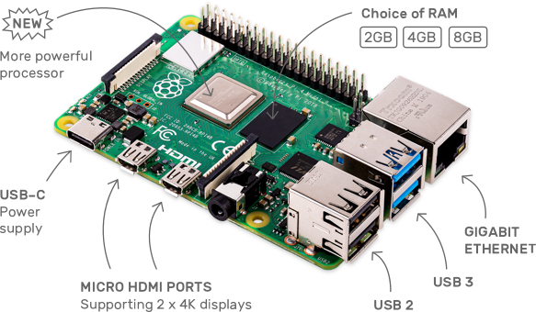
- https://www.raspberrypi.org/
- https://raspberrypi.tilburgs.com/


