Printer

Canon i350
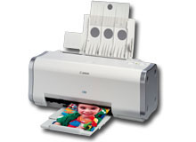Canon i350
- Driver
- Handleiding
- Setup
- Specificaties
- Technische specificaties

