Nikon D70 Speieglreflexcamera
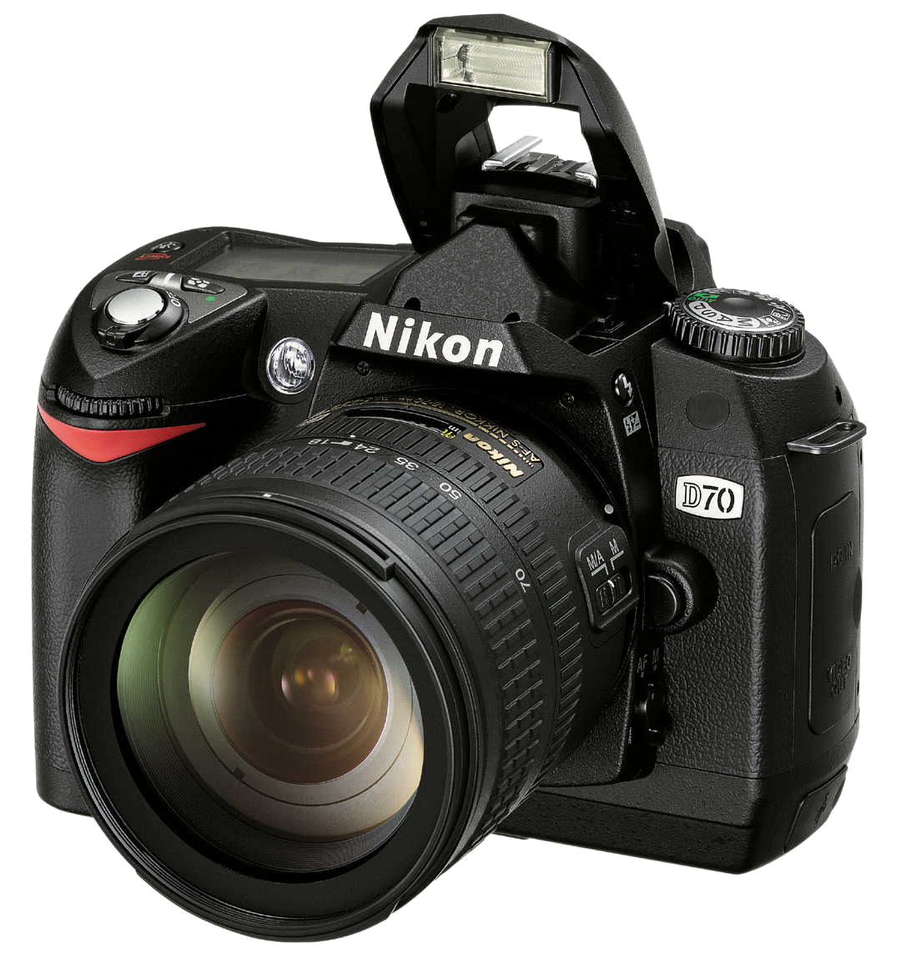
- http://en.wikipedia.org/wiki/Nikon_D70
- http://www.dpreview.com/reviews/nikond70
- Nederlandse handleiding

