Nest learning thermostaat V3
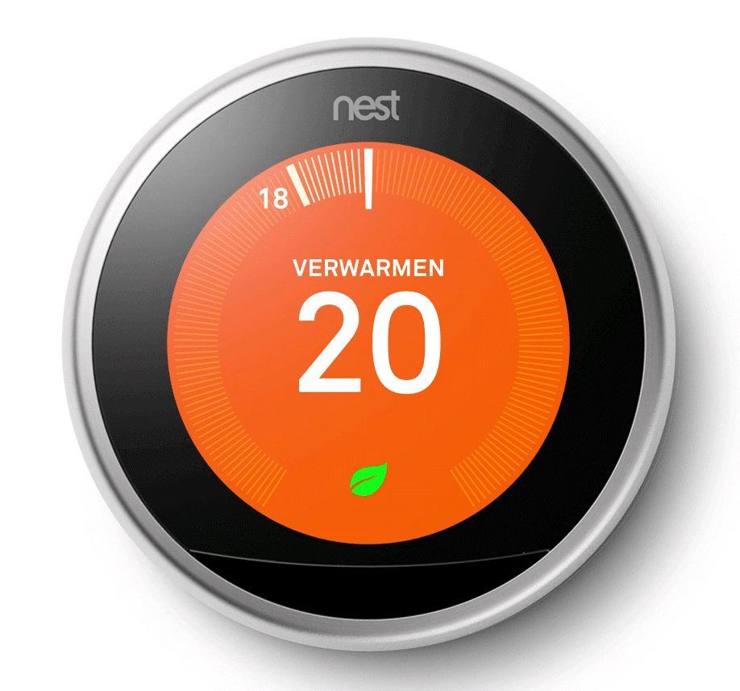Nest learning thermostat V3
- https://nest.com/nl/support/article/How-to-install-your-Nest-Learning-Thermostat
- Introductiegids (NL)
- Installatiehandleiding (NL)

