Kobo Glo
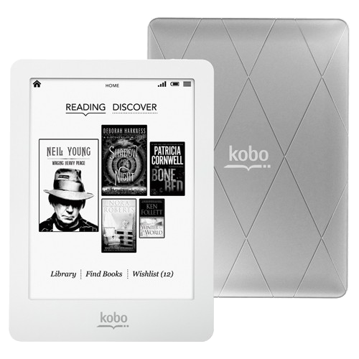Kobo Glo
- http://nl.kobo.com/userguides
- www.kobo.com/help
- Quick start guide
- Handleiding

