Joying 2Din Head Unit Universal Android Car Radio StereoMultimedia Player
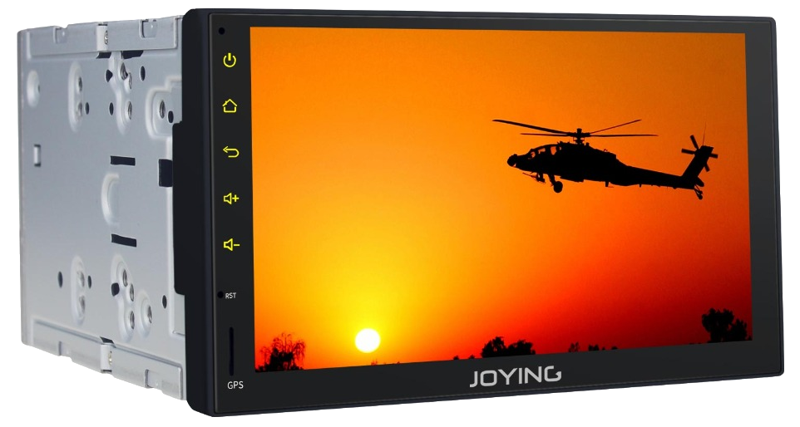
Rooten
- https://hvdwolf.github.io/Joying-RootAssistant/
- https://forum.xda-developers.com/android-auto/android-head-units/how-to-root-joying-devices-t3614933
Alternatieve firmware
- https://forum.xda-developers.com/android-auto/mtcd-software-development/rom-malaysk-roms-mtcd-device-t3598908
- https://forum.xda-developers.com/android-auto/mtcd-software-development/rom-malaysk-roms-px5-2-4-gb-8-0-android-t3762724

Passwords
Factory reset | 3368
Developer options | 3368

Troubleshooting
- 3G dongel werkt niet
  - PPP Widget 3
- Tomtom voice guidance werkt niet
- Tomtom 3D routekaartjes werken niet
  - https://en.discussions.tomtom.com/tomtom-go-mobile-and-navigation

Settings
Anykey Boot | If you choose this one, then when you turn on the car radio, any button can replace the power button to turn on the radio
Brake Set | That is for you to choose whether or not you can watch the video when you drive the car
Auto Navi | It is for when you turn on the car radio, turn on the Navigation automatically
Rear View | It is for you to choose the reverse image as the mirror image or original image
MCU panel Key | , it is for lock the buttons at the left of the panel
Door lock interface | It is control your car door lock
Automatic start and stop | Sorry for i haven't find it in the carmediasetting

