HP 4510S notebook
Komt met XP downgrade.
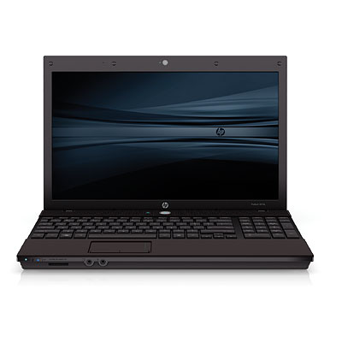HP 4510S
- http://h10010.www1.hp.com/wwpc/us/en/sm/WF06a/321957-321957-64295-3929941-3955552-3934828.html

