Comfort Way WMF280 3G Wifi router
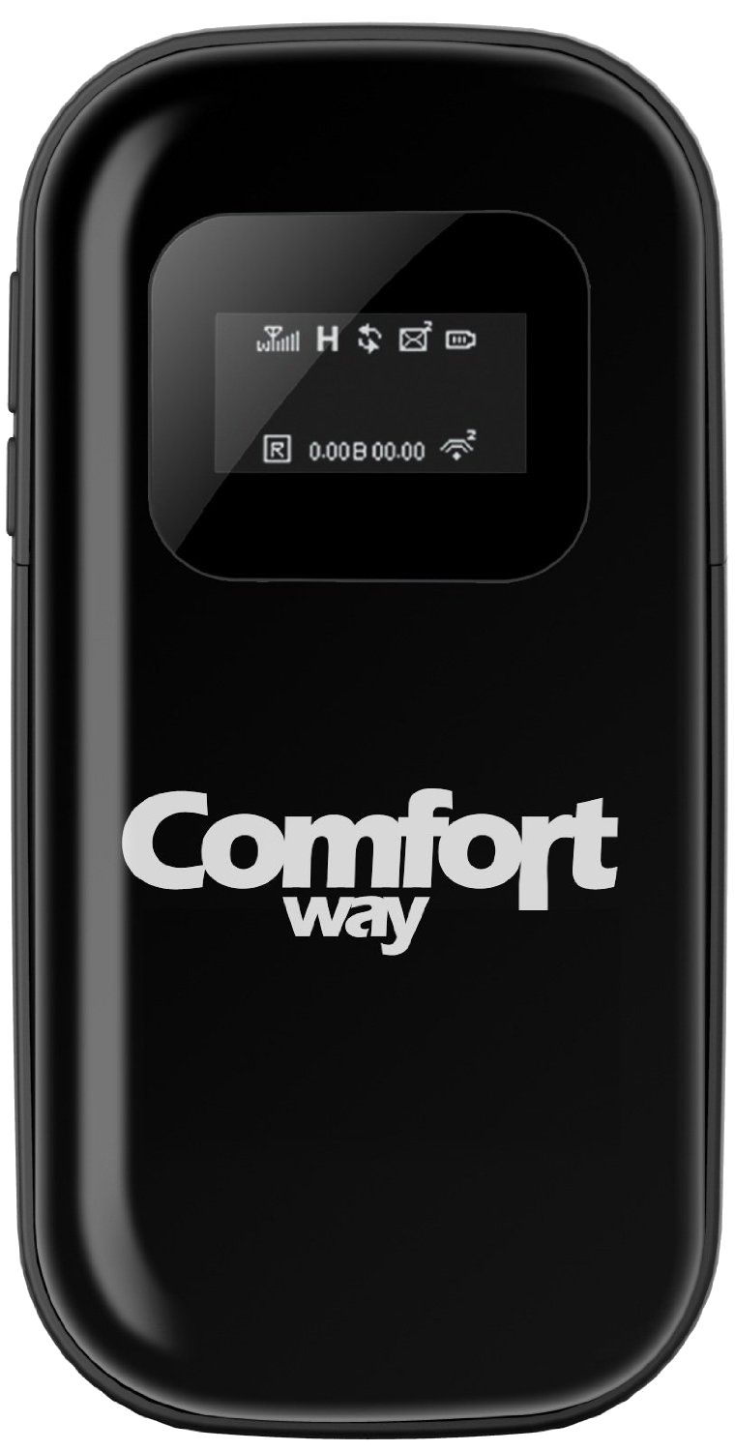Comfort Way Mifi
(EMAIL) | support@comfortway.com
(WWW) | http://www.comfortway.com
Aan/uit knop 5+ seconden ingedrukt houden.

