APC BE550G-GR power saving back-UPS
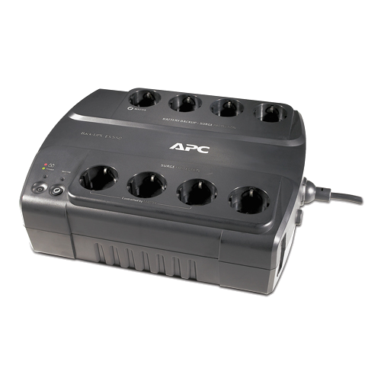
- http://www.apc.com/resource/include/techspec_index.cfm?base_sku=BE550G-GR&ISOCountryCode=nl
- User manual

